Nicolas Boussenina

Nicolas Oulianov

Julien Liu

Real time Big Data Search & Analytics

Lab 1

1.1 Flights Dashboard

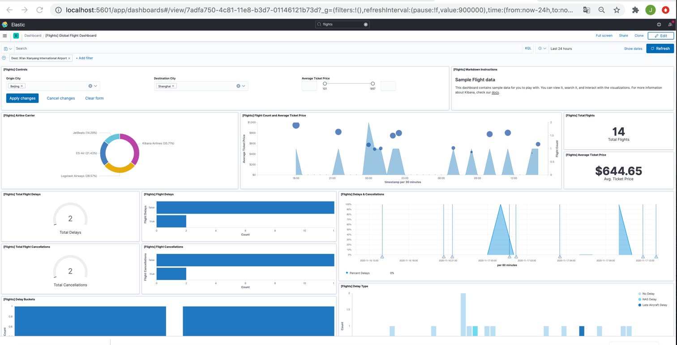

1.1 Please specify in your report the total number of documents of each index.

ba* : 1 000hits

logstash* : 14 005 hits

shakes* : 111 396 hits

(screens below)

1.2 Please do some screenshots of at least 1 search or filter you applied on each index.

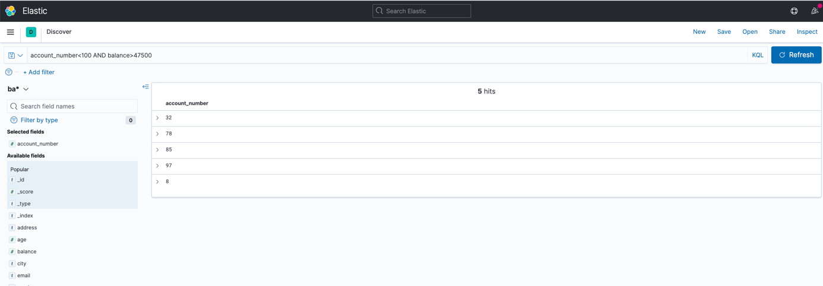

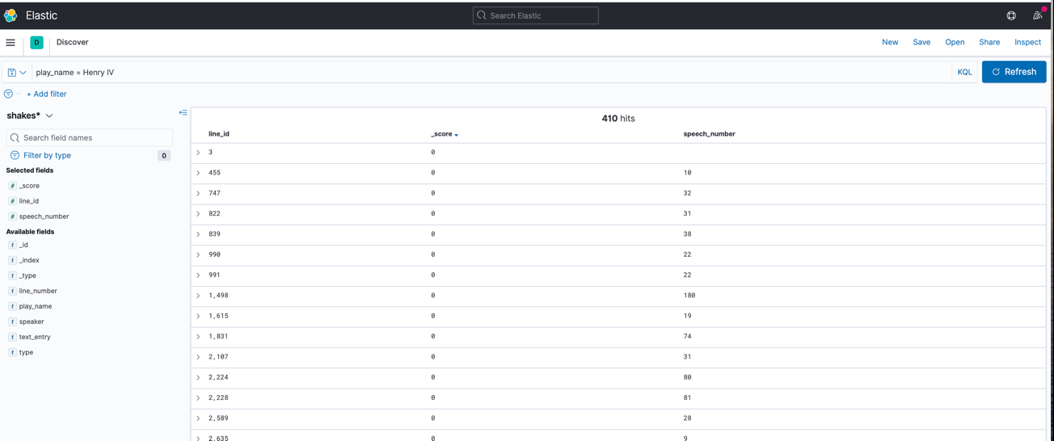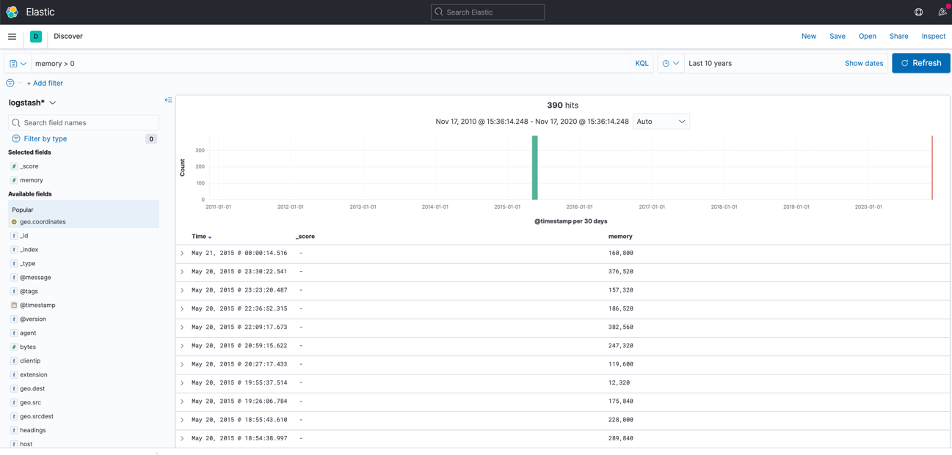

1.3 Do a screenshot of the dashboard and add it to your report:

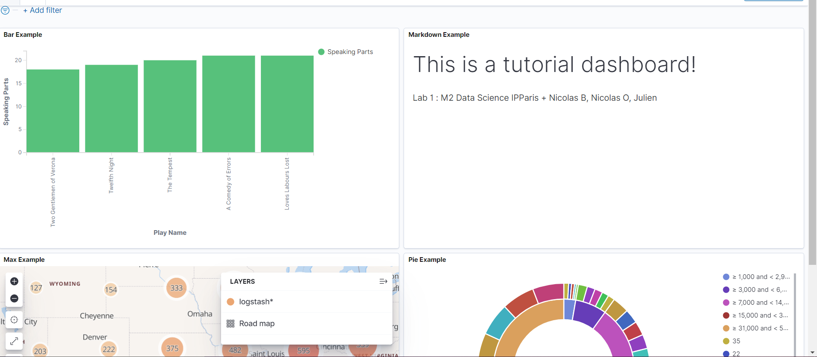

Lab 2

2.1 Do a screenshot of the monitoring and add it to your report:

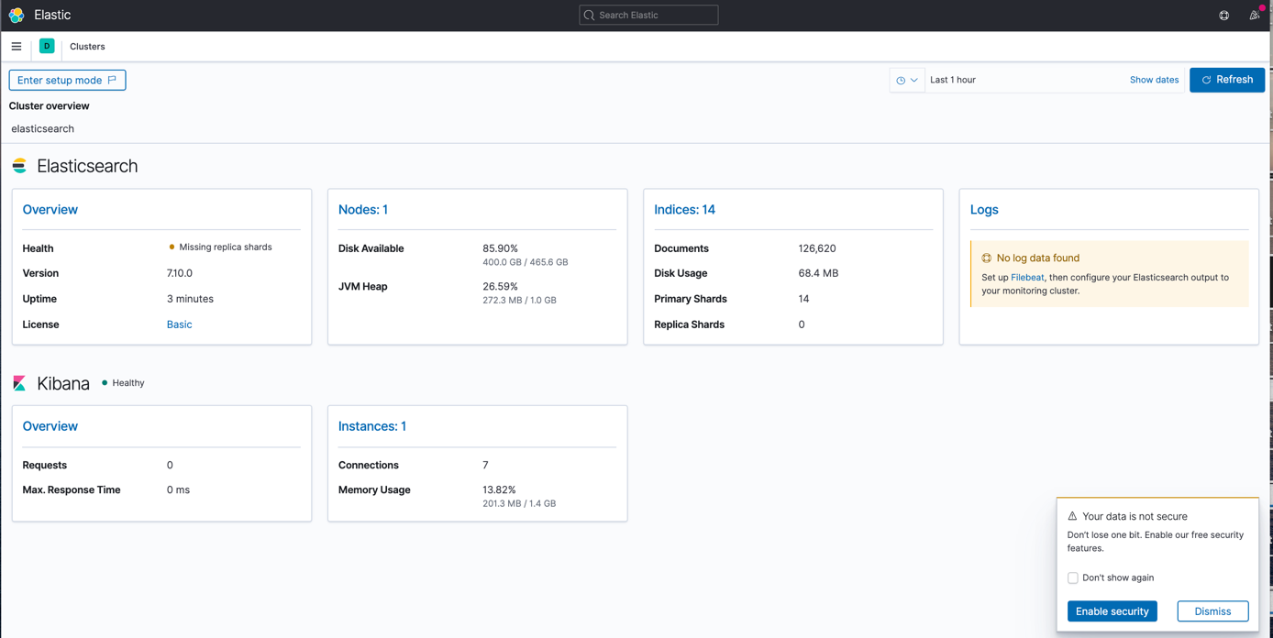

What is their status? Do they have unassigned shards?

Their status is “Yellow” and they have unassigned shards.

2.2 Do a screenshot of indices monitoring and add it to your report

Why is there unassigned shards for all our indices created in Lab 1 ?

There are unassigned shards because we only have 1 node, so replica shards aren’t assigned to any nodes.

2.3 Do a screenshot of the monitoring of the “bank” index and add it to your report

2.4 Do a screenshot of the monitoring of the “bank” index, after the addition of 1 node and add it to your report. Comment about what happen on the bank index monitoring page ?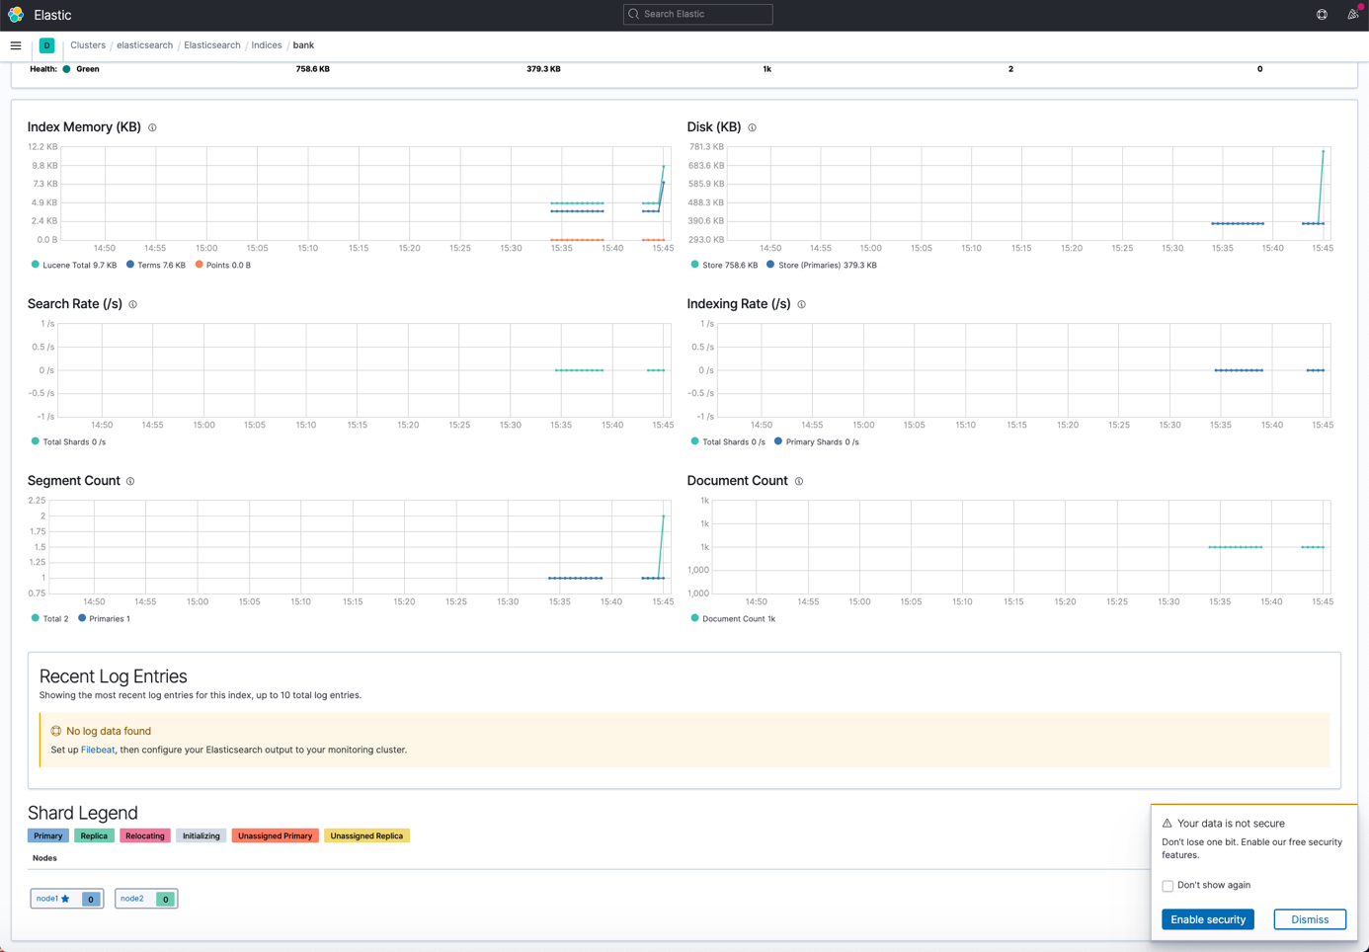

We added a node to our cluster. Now, all the shards are assigned to a node. We can see on the screenshot that the primary shard is assigned to node1 and the replica to node2.

2.5 Do a screenshot of the monitoring of the “bank” index, after the addition of 2 nodes and add it to your report. Comment about what happen on the bank index monitoring page?

The number of replicas for the index “bank” is set to 1. Here, the primary shards is assigned to node3 and the replica shard to node2. We do not see node1 here because we only have 1 replica.

2.6 Do a screenshot of indices monitoring, after the addition of 2 nodes and add it to your report

2.7 Do a screenshot of the monitoring of the “bank” index, after reducing number of replica to 0 and add it to your report. What happened ?

We set the number of replica to 0. So, we only have 1 primary shard assigned to node3 for bank index.

2.8 Do a screenshot of the monitoring of the “bank” index, after increasing number of replica to 2 and add it to your report. What happened ?

We have to 2 replicas. Now the primary shard is assigned to node3 and one replica is assigned to node2 and another replica to node1.

Lab3

3.1 Do a screenshot of your search results and add it to your report

Add the exact number of hits in your report that you will get from this request :

The exact number of hits from this request is 32484 ( screen below )

3.2 Do a screenshot of your search profiler and add it to your report :

3.3 Do a screenshot of the result of this command :

3.4 Do a screenshot of this search query results and add it to your report :

3.5 Do copy / paste all the queries you wrote in Dev Tools during this lab and add it to your report :

PUT /shakespeare/_settings

{

"settings": {

"index.blocks.write": true

}

}

POST shakespeare/_split/shakespeare-catalog

{

"settings": {

"index.number_of_shards": 2

}

}

DELETE shakespeare

GET /shakespeare-catalog/_search

{

"query": {

"match": {

"text_entry": "The edge of war"

}

}

}

GET /shakespeare-catalog/_search

{

"track_total_hits": true,

"query": {

"match": {

"text_entry": "The edge of war"

}

}

}

GET /shakespeare-catalog/_search

{

"query": {

"match": {

"text_entry": {

"query": "The edge of war",

"operator": "AND"

}

}

}

}

GET /shakespeare-catalog/_search

{

"query": {

"match": {

"text_entry": {

"query": "The edge of war",

"minimum_should_match": "2"

}

}

}

}

GET /shakespeare-catalog/_search

{

"query": {

"match": {

"text_entry": {

"query": "The edge of war",

"minimum_should_match": "2"

}

}

},

"sort": [

{

"_score": {

"order": "asc"

}

}

]

}

GET /shakespeare-catalog/_mapping

PUT /shakespeare-catalog-2

{

"mappings": {

"properties": {

"speaker": {

"type": "keyword"

},

"play_name": {

"type": "keyword"

},

"line_id": {

"type": "integer"

},

"speech_number": {

"type": "integer"

},

"text_entry": {

"type": "text",

"fields": {

"english": {

"type": "text",

"analyzer": "english"

}

}

}

}

}

}

POST _reindex

{

"source": {

"index": "shakespeare-catalog"

},

"dest": {

"index": "shakespeare-catalog-2",

"version_type": "internal"

}

}

GET /_cat/indices/

GET /shakespeare-catalog-2/_search

{

"query": {

"match": {

"text_entry.english": {

"query": "The edge of war",

"minimum_should_match": "2"

}

}

},

"sort": [

{

"_score": {

"order": "asc"

}

}

]

}

GET /_analyze/

{

"analyzer": "default",

"text":"The edge of war"

}

GET /_analyze/

{

"analyzer": "english",

"text":"The edge of war"

}

GET /shakespeare-catalog-2/_search

{

"query": {

"match": {

"text_entry.english": {

"query": "The edge of war"

}

}

},

"sort": [

{

"_score": {

"order": "asc"

}

}

]

}

GET /shakespeare-catalog-2/_search

{

"query": {

"match": {

"text_entry.english": {

"query": "The edge of war"

}

}

},

"size": 20

}

3.6 Do a screenshot of your aggregation query results and add it to your report :

3.7 Do a screenshot of your search & aggregation query results and add it to your report :

3.8 Do a screenshot of the response in the inspect panel and add it to your report :

Interval: Auto

Interval daily:

3.9 Do a screenshot of the response in the inspect panel and add it to your report :

3.10 Do a screenshot of the response in the inspect panel and add it to your report :

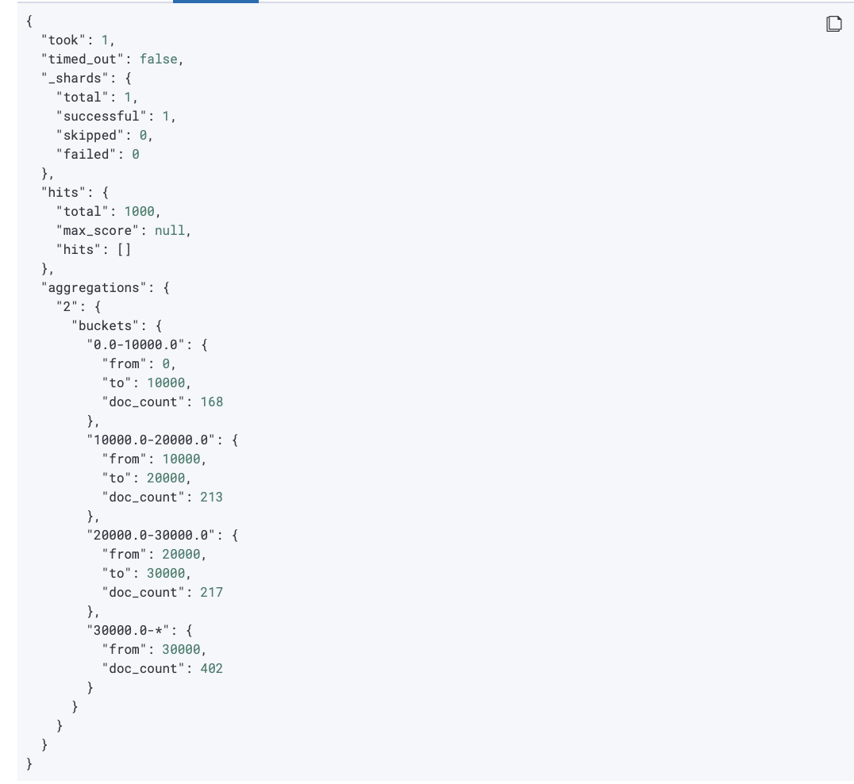

3.11 Do a screenshot of the visualization and settings and add it to your report :

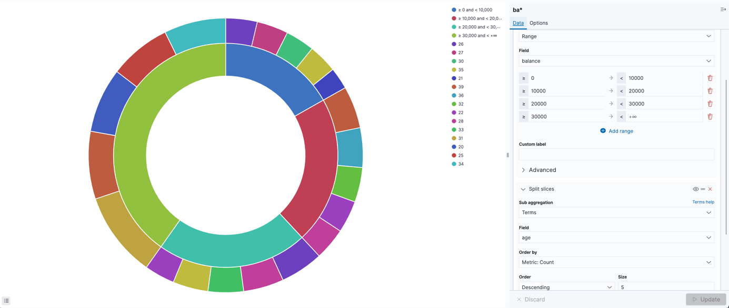

3.12 Do a screenshot of the dashboard and add it to your report

